APEX Planet Cyber security & Ethical Hacking Program

Lab Setup Report
Setting up an virtual environment for cybersecurity and ethical hacking program in Apex planet by using virtual box
Attacker as Kali Linux
Target as Metasploitable

VM List Snapshot
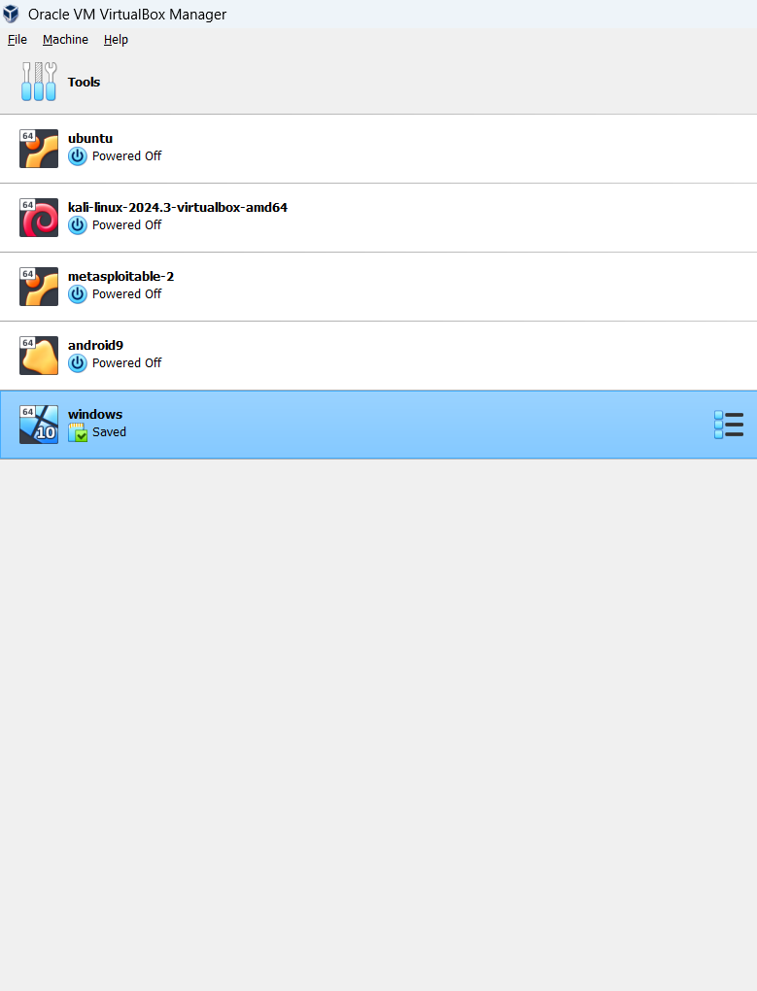

Kali Linux VM Details (Attacker)

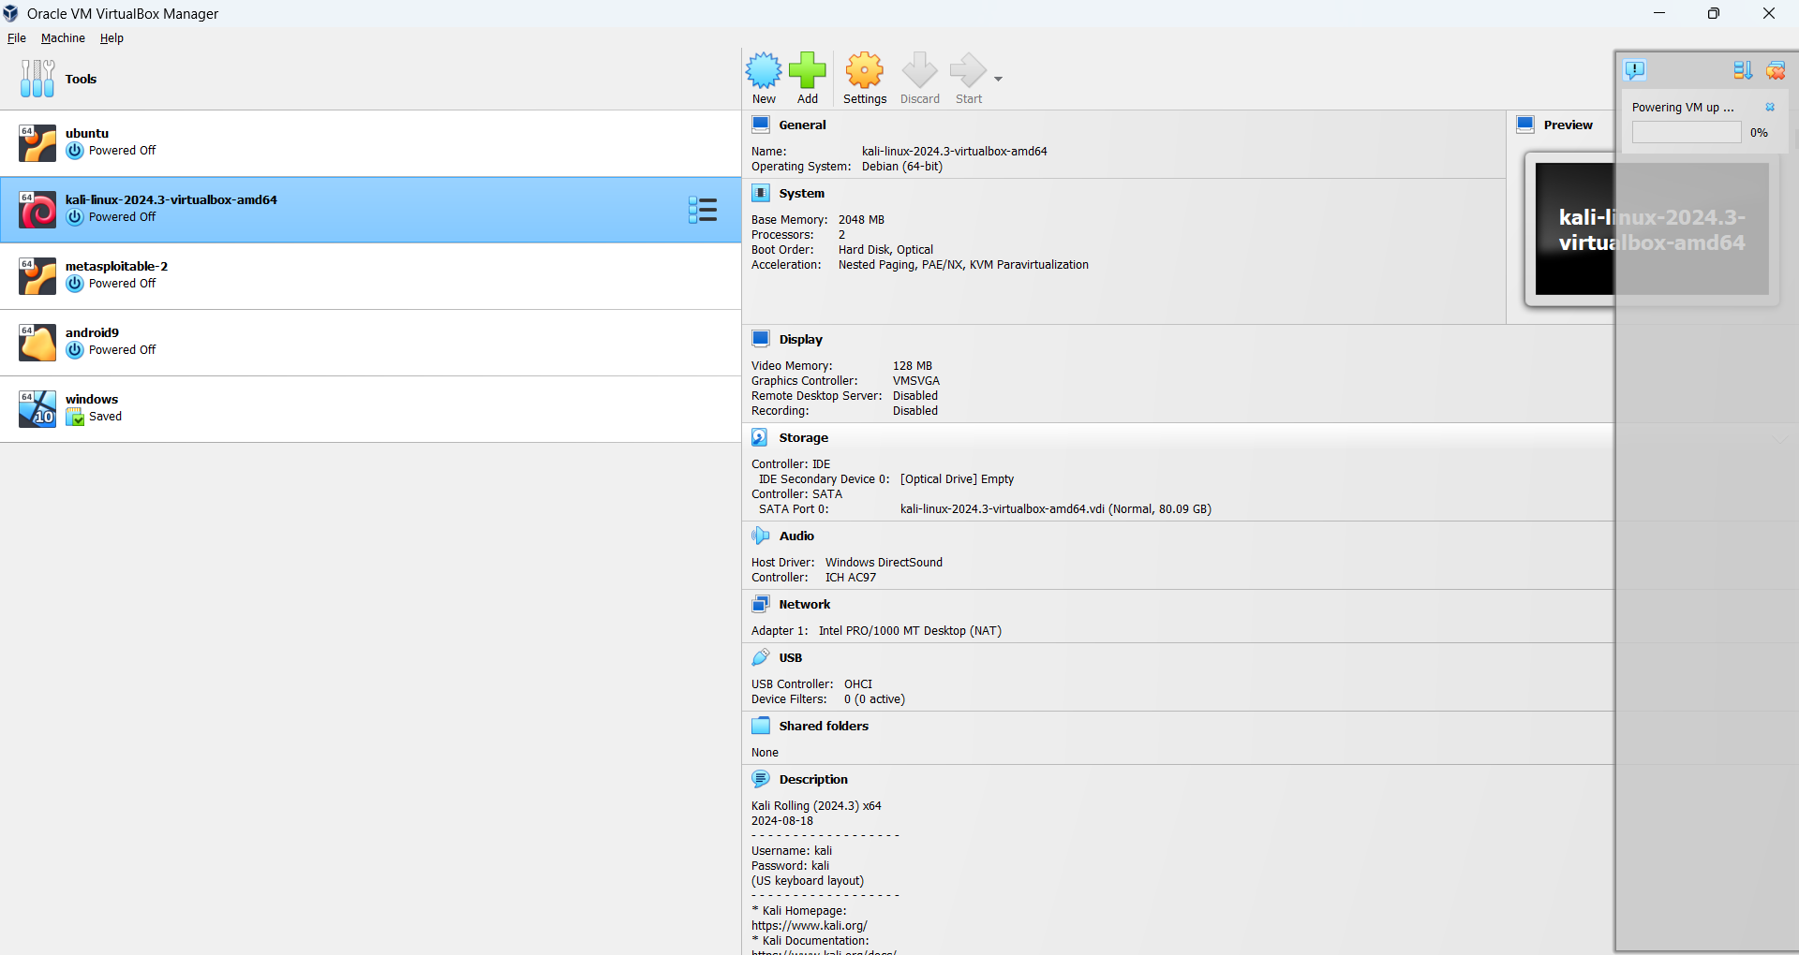

Metasploitable VM Details (Target)

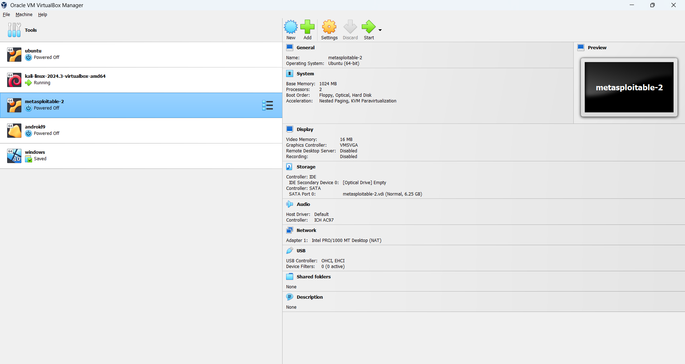

Kali Desktop

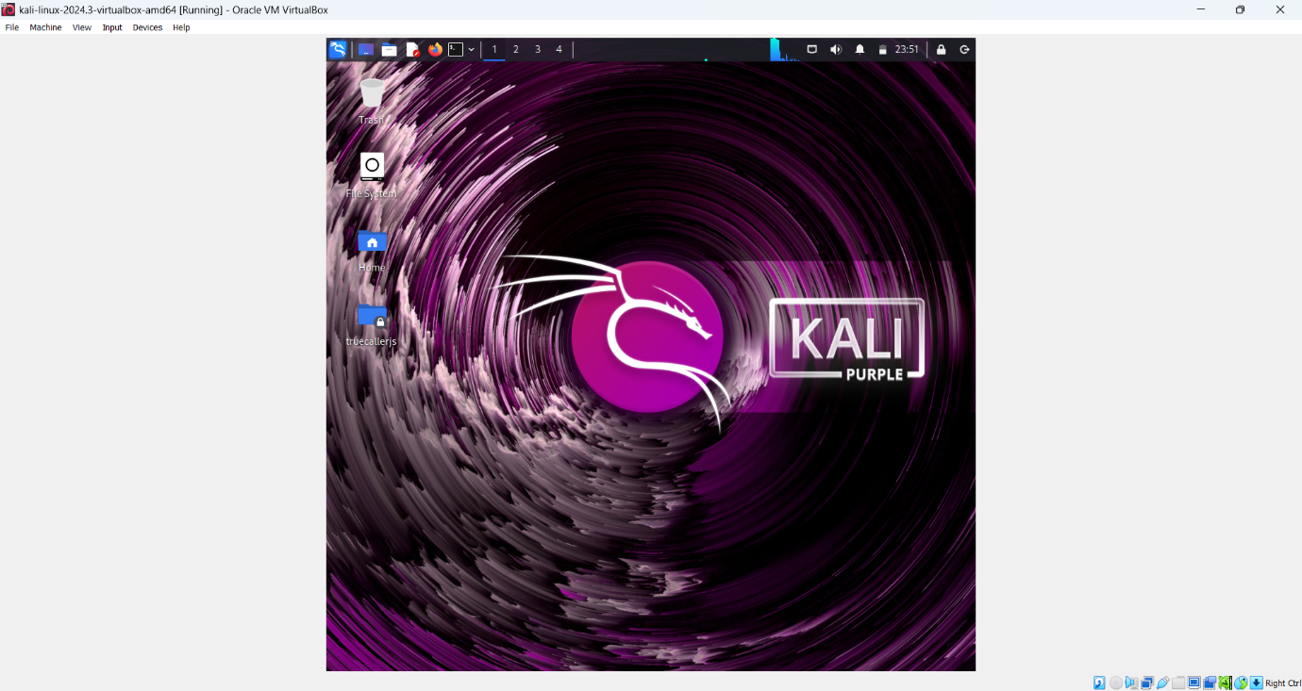

Metasploitable Desktop & ifconfig

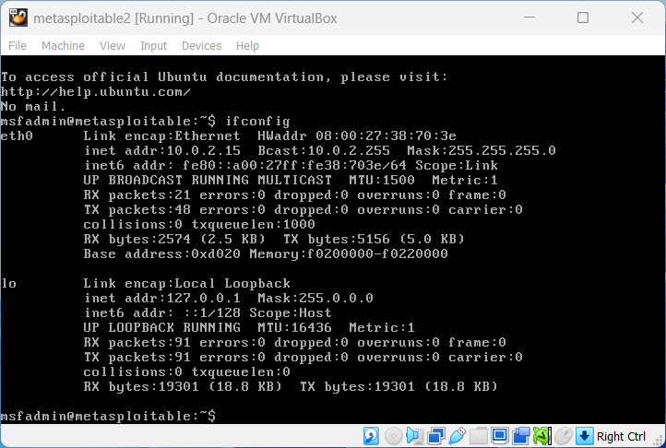

Kali ifconfig and ping
